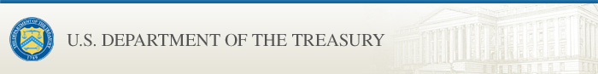

OFAC SDN List Update: Belarus Designations; Issuance of Belarus General License 3 and related Frequently Asked Questions
U.S. Department of the Treasury sent this bulletin at 06/21/2021 10:32 AM EDT
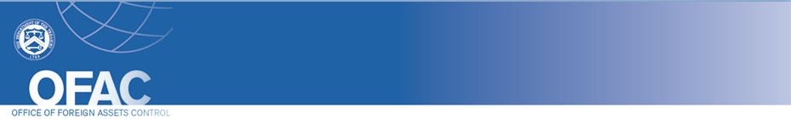
- Search OFAC's Sanctions Lists  - OFAC News and Recent Actions  - Sanctions FAQs  - Press Releases  - Contact OFAC | Having trouble viewing this email? View it as a Web page.  You are subscribed to SDN and/or Office of Foreign Assets Control (OFAC) Recent Actions updates for the U.S. Department of the Treasury.  Update to OFAC's list of Specially Designated Nationals (SDN) and Blocked Persons  The Department of the Treasury’s Office of Foreign Assets Control (OFAC) has issued Belarus General License 3 and related FAQs 912 and 913. Additionally, OFAC has updated its Specially Designated Nationals and Blocked Persons List.  The SDN list has recently been updated. Please visit this page to access the latest version of the SDN list. Check this page periodically as it may also be updated if a new list-related format or product is offered.

To update your preferences or to sign up for additional OFAC email lists, click on the "Manage Preferences" link in the bottom of the email.


POWERED BY


