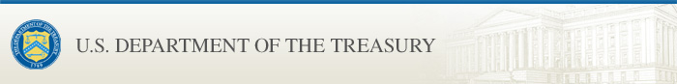

OFAC SDN List Update: Hostages and Wrongfully Detained U.S. Nationals Designations; Counter Narcotics Designations and Removal; Iran-related Designations Updates and Removals; Issuance of Cyber-related General License and Amended Frequently Asked Questions
U.S. Department of the Treasury sent this bulletin at 04/27/2023 01:31 PM EDT
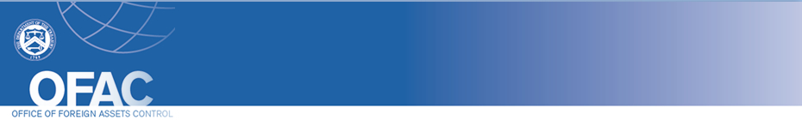
- Search OFAC's Sanctions Lists  - OFAC Recent Actions  - Sanctions FAQs  - Press Releases  - Contact OFAC | Having trouble viewing this email? View it as a Web page.  You are subscribed to SDN and/or Office of Foreign Assets Control (OFAC) Recent Actions updates for the U.S. Department of the Treasury.  OFAC SDN List Update: Hostages and Wrongfully Detained U.S. Nationals Designations; Counter Narcotics Designations and Removal; Iran-related Designations Updates and Removals; Issuance of Cyber-related General License and Amended Frequently Asked Questions  The Department of the Treasury's Office of Foreign Assets Control (OFAC) is issuing Cyber-related General License 1C, "Authorizing Certain Transactions with the Federal Security Service." OFAC is also amending three Cyber-related Frequently Asked Questions (501, 502, 503).  Additionally, the SDN list has been updated. Please visit this page to access the latest version of the SDN list. Check this page periodically as it may also be updated if a new list-related format or product is offered.  For more information on today's action, please visit this page.

To update your preferences or to sign up for additional OFAC email lists, click on the "Manage Preferences" link in the bottom of the email.

POWERED BY


